**ATM Simulator Machine**



Done by Gunaseelan N

Submitted to Junie Denny Solomon

Summary

* The topic of my project is the bank Management System which contains all create the ATM machine account created.
* Enter the login page we have account number enter the

Card number and Pin Number.

* Customer Create new account in Login page SIGNUP clicked next page is Enter the personal Details.
* Next page enter additional data, next page is Account Details create in automatically.
* Customer account data save database after we want enter used card number, password.
* Card number and password very secure in the database .
* The Transaction list store in the database withdraw and deposits Which data transaction full list in store the database ,when we are want to the customer details we have see the details.
* Database only see the which persione maintain the data only see it.

**Introduction**

* The project is Atm machine account create in the customer create the account in easy way to open the account the main reason .
* Customer personal details enter the easy way in the ATM machine .
* After we enter the details automatically create the card number and pin number to stroe in database.
* Create text area entre the amount and card number and button create the models in the ATM project.
* This ATM project highly security in our data ,only security person access the data.

**Tools used**

* Apache Netbeans
* Sqlyog

**Core language**

Java is a **programming language** and a **platform**. Java is a high level, robust, object-oriented and secure programming language.

Java was developed by Sun Microsystems (which is now the subsidiary of Oracle) in the year 1995. James Gosling is known as the father of Java. Before Java, its name was Oak. Since Oak was already a registered company, so James Gosling and his team changed the name from Oak to Java.

**Hardware And Software:**

Hard disk: 512GB

RAM: 16GB

Processer: intel i5

Graphics card: intel iRlSxe

Operating System: Windows11

Programming language: core java

Database: MySql

**The main Function used In java :-**

**Java swing**

* The javax.swing package provides classes for java swing API such as JButton, JTextField, JTextArea, JRadioButton, JCheckbox, JMenu, JColorChooser etc.

**Java Class**

* The JButton class is used to create a labeled button that has platform independent implementation. The application result in some action when the button is pushed. It inherits AbstractButton class.

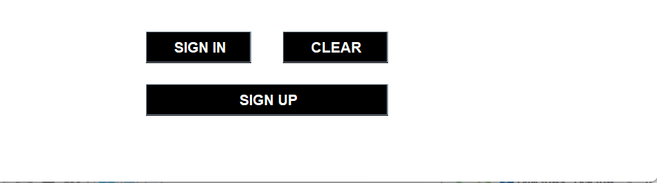

**Java jlabel**

* The object of JLabel class is a component for placing text in a container. It is used to display a single line of read only text. The text can be changed by an application but a user cannot edit it directly. It inherits JComponent class.

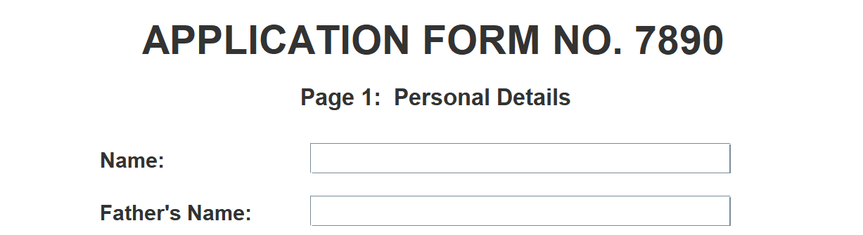

**Java jtextfield**

* The object of a JTextField class is a text component that allows the editing of a single line text. It inherits JTextComponent class.

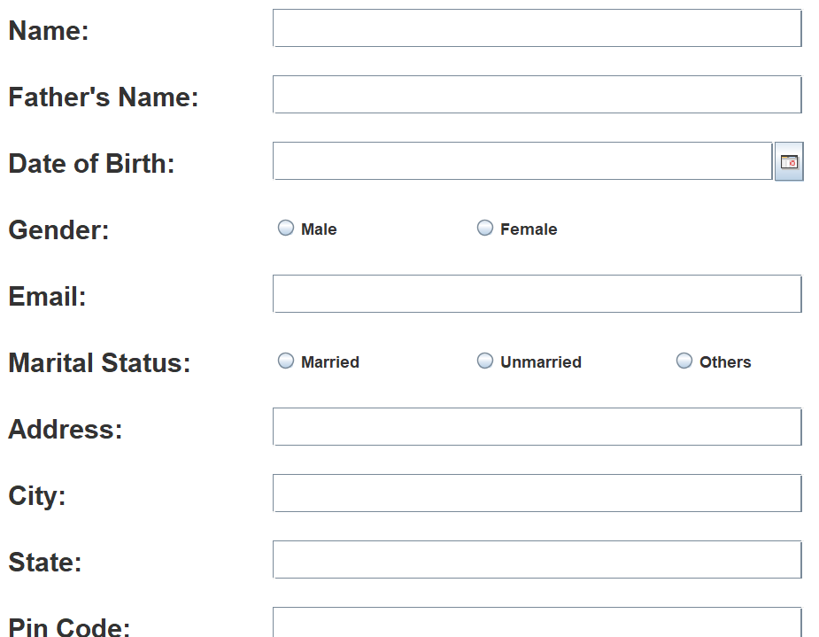

**Java jCheckBox**

* The JCheckBox class is used to create a checkbox. It is used to turn an option on (true) or off (false). Clicking on a CheckBox changes its state from "on" to "off" or from "off" to "on ".It inherits [JToggleButton](https://www.javatpoint.com/java-jtogglebutton) class.

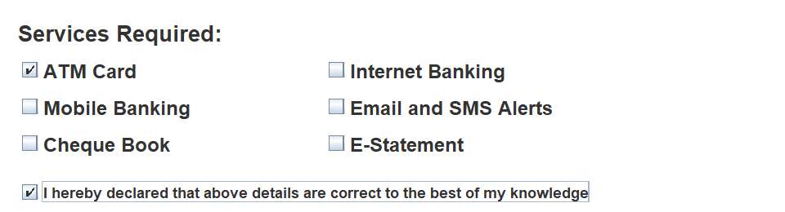

**Java JFrame**

* The javax.swing.JFrame class is a type of container which inherits the java.awt.Frame class. JFrame works like the main window where components like labels, buttons, textfields are added to create a GUI.
* Unlike Frame, JFrame has the option to hide or close the window with the help of setDefaultCloseOperation(int) method.

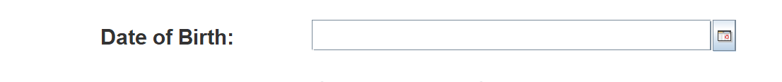

**Java Action Listener interface**

* The Java Action Listener is notified whenever you click on the button or menu item. It is notified against Action Event. The Action Listener interface is found in java.awt.event [package](https://www.javatpoint.com/package). It has only one method: action Performed().

**Java mouse Listener interface**

* The Java MouseListener is notified whenever you change the state of mouse. It is notified against MouseEvent. The MouseListener interface is found in java.awt.event package. It has five methods.

**Java Layout manager**

* The LayoutManagers are used to arrange components in a particular manner. The **Java LayoutManagers** facilitates us to control the positioning and size of the components in GUI forms. LayoutManager is an interface that is implemented by all the classes of layout managers. There are the following classes that represent the layout managers:
* java.awt.BorderLayout
* java.awt.FlowLayout
* java.awt.GridLayout
* java.awt.CardLayout
* java.awt.GridBagLayout
* javax.swing.BoxLayout
* javax.swing.GroupLayout
* javax.swing.ScrollPaneLayout
* javax.swing.SpringLayout etc.

**java Date jar File**

* The java.date, java.util, java.sql and java.text packages contains classes for representing date . Following classes are important for dealing with date in Java.



**Application preview:-**

**LOGIN PAGE:**

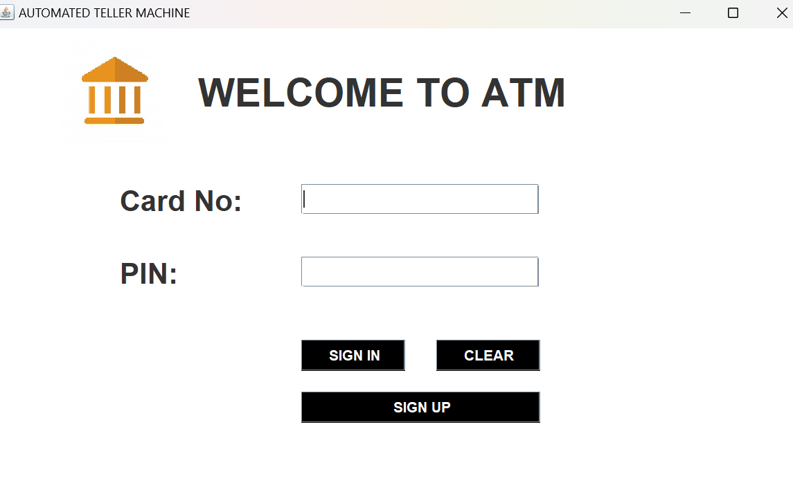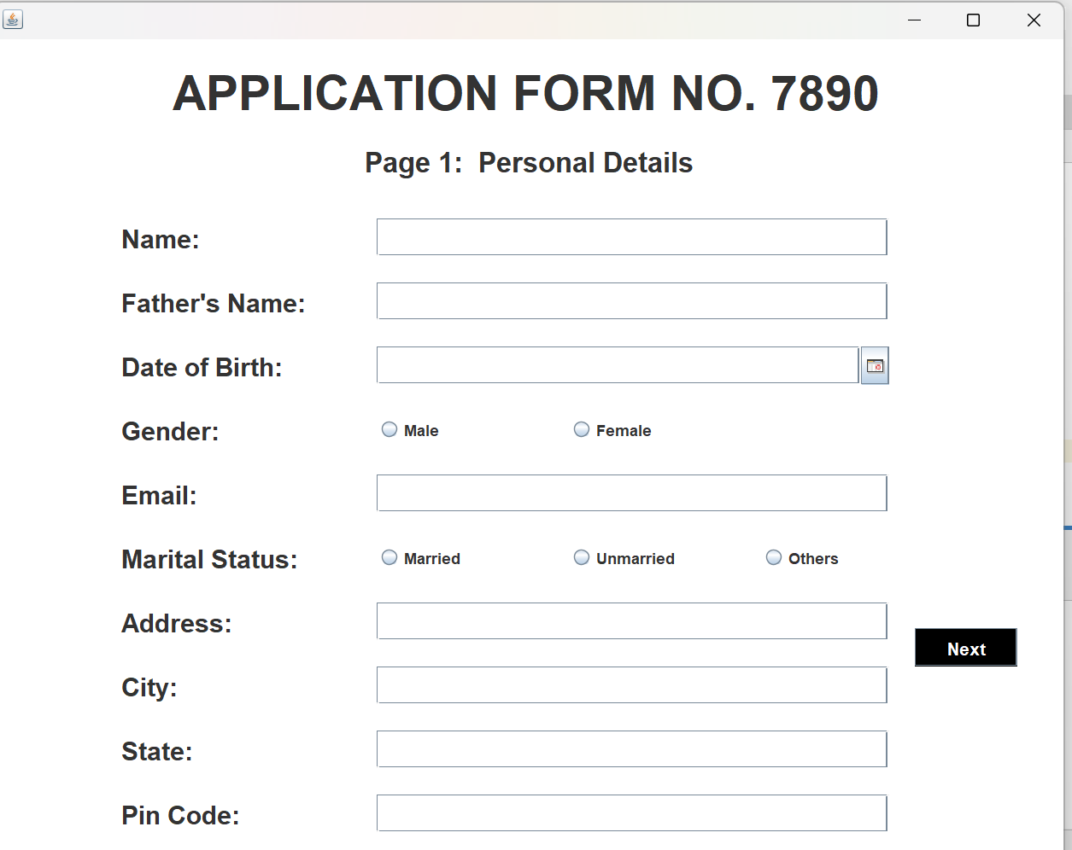

**Personal Details:**

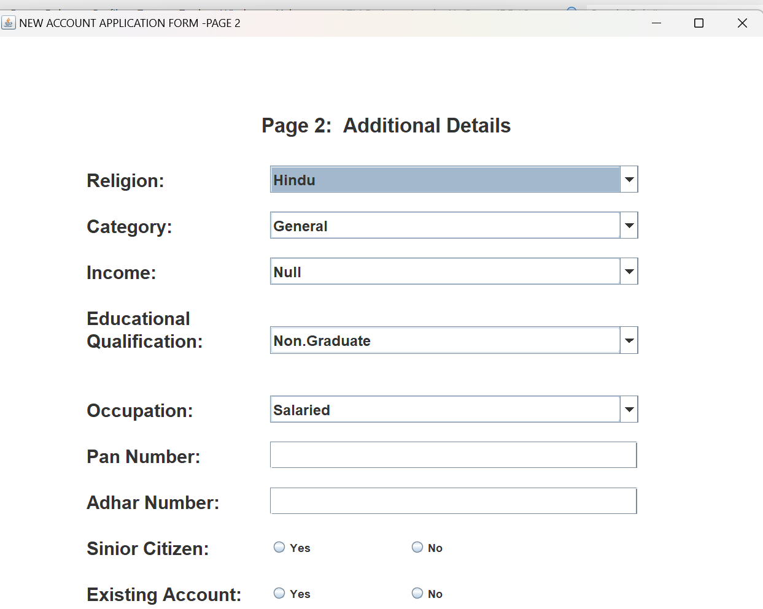

**Account Details:**

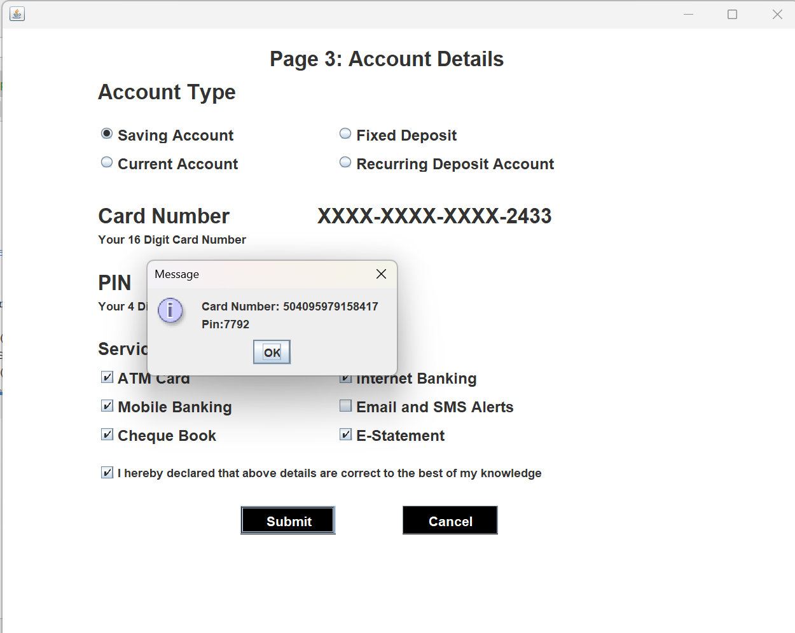

**Transaction:**

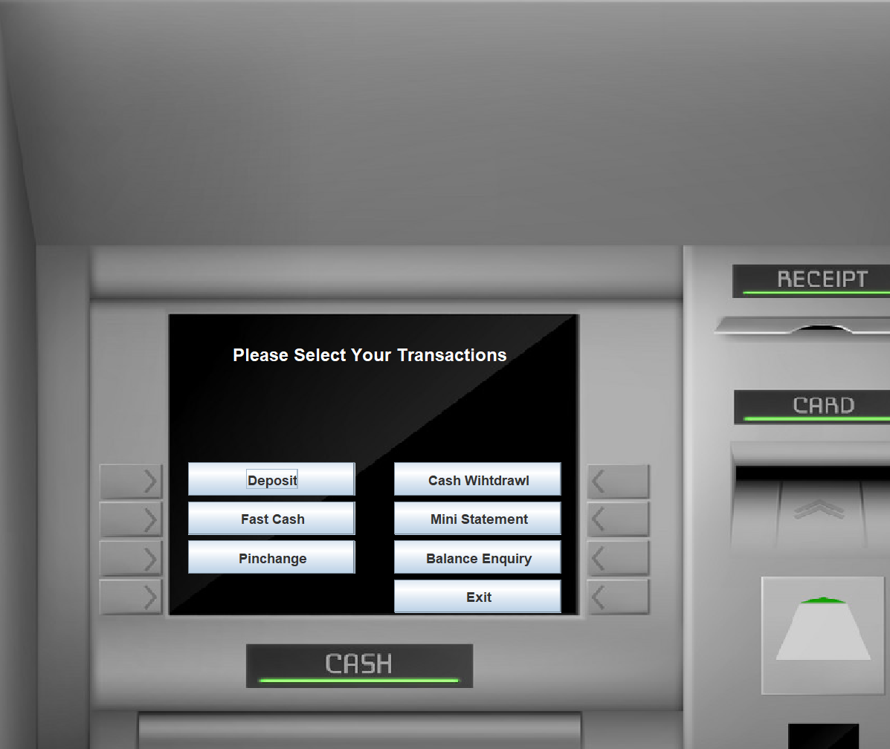

**Deposits Details:**

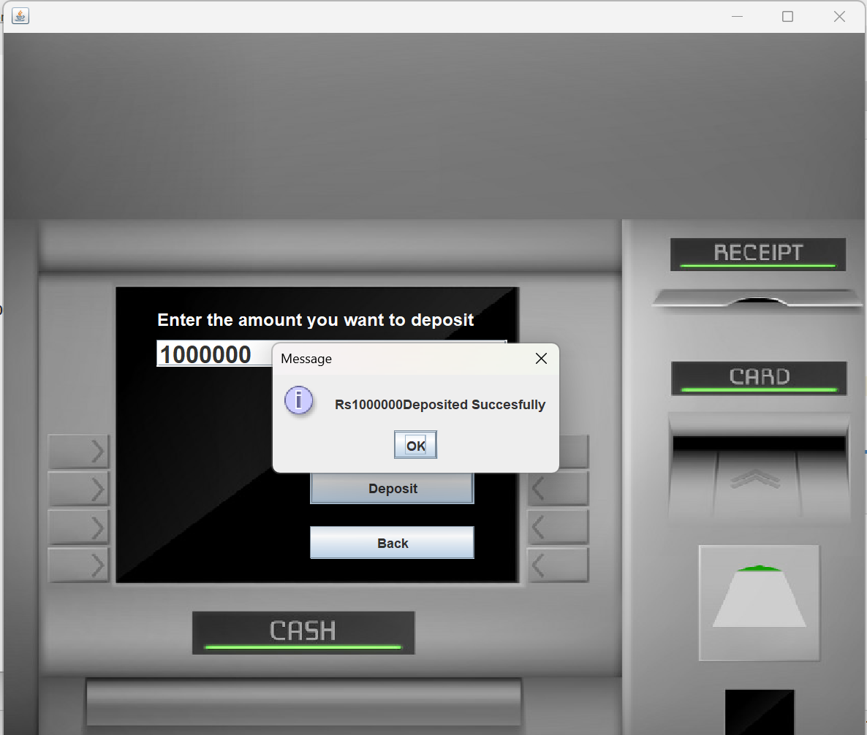

**Withdraw Amount:**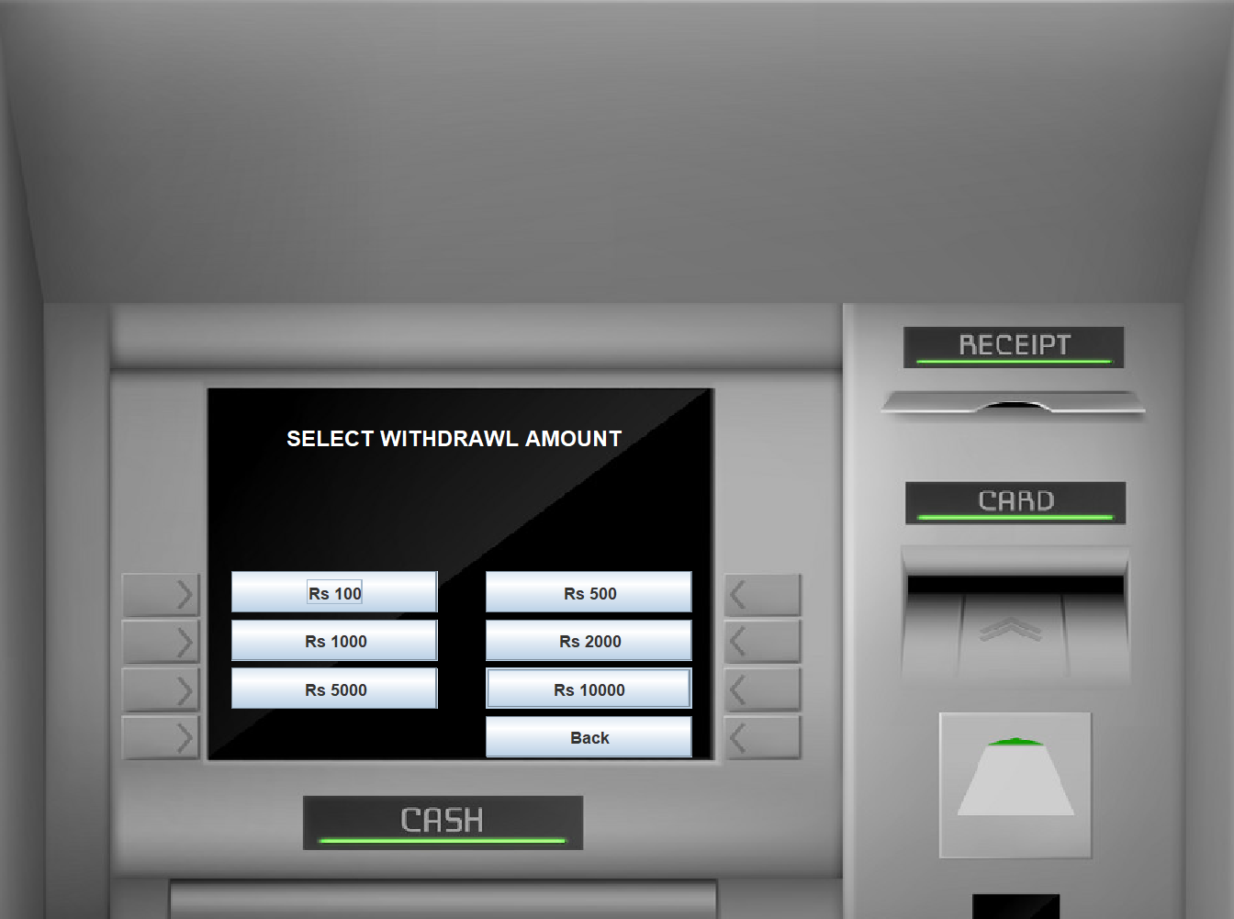

**Withdraw Successfully:**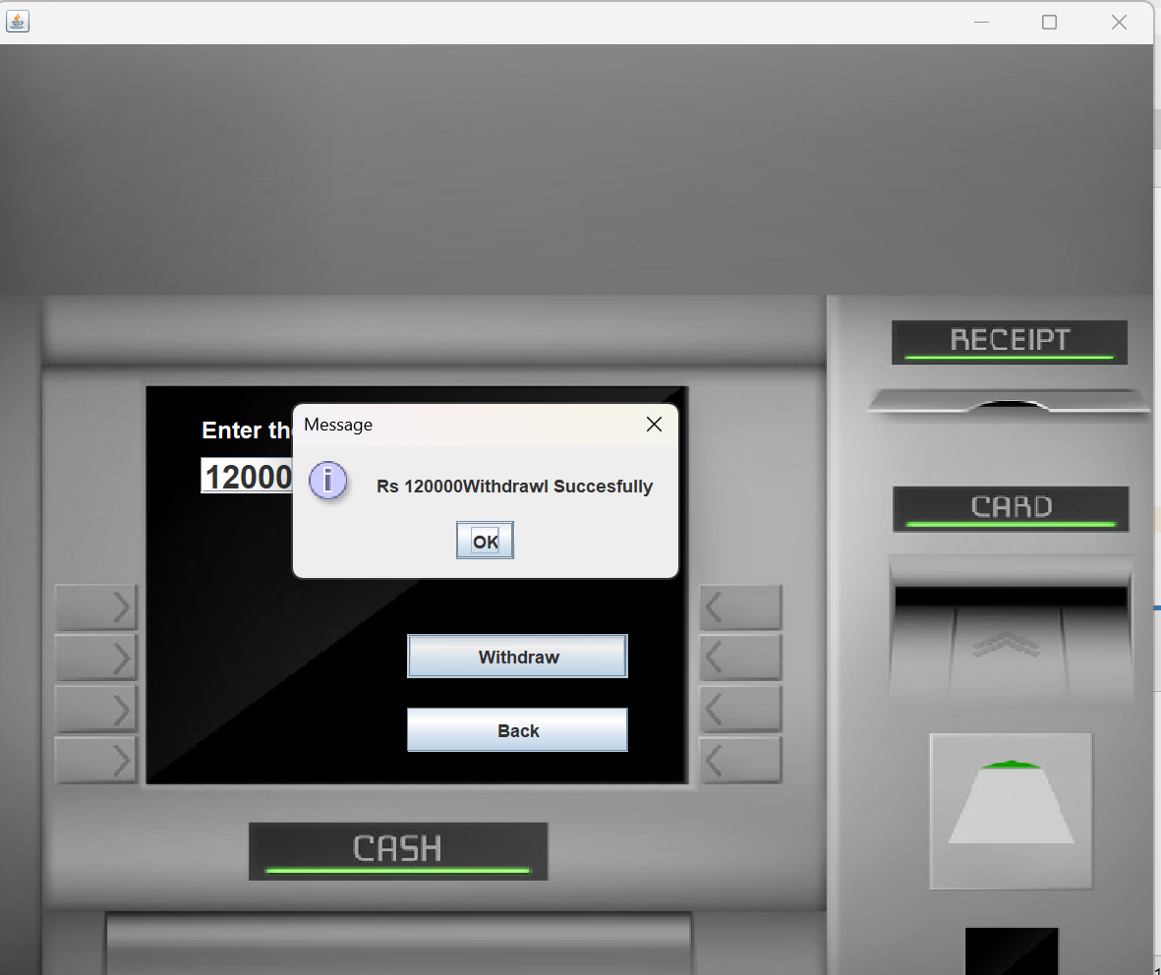

**Pin change:**

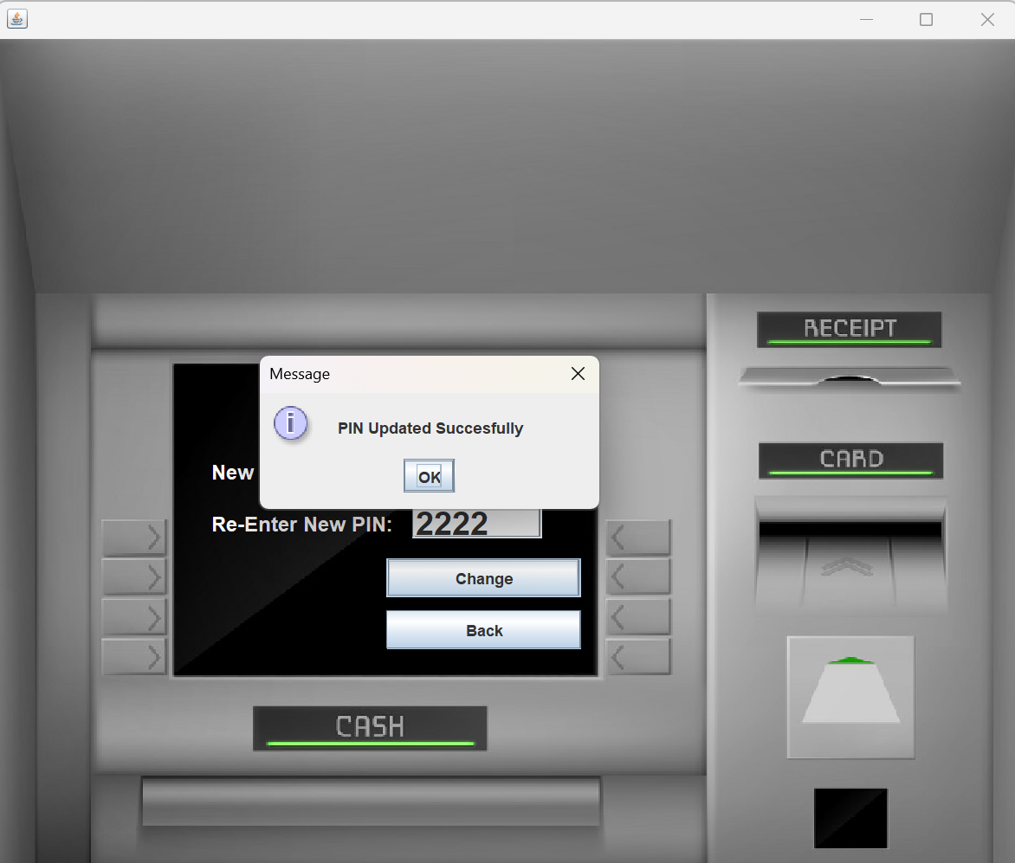

**Login DataBase Table:**

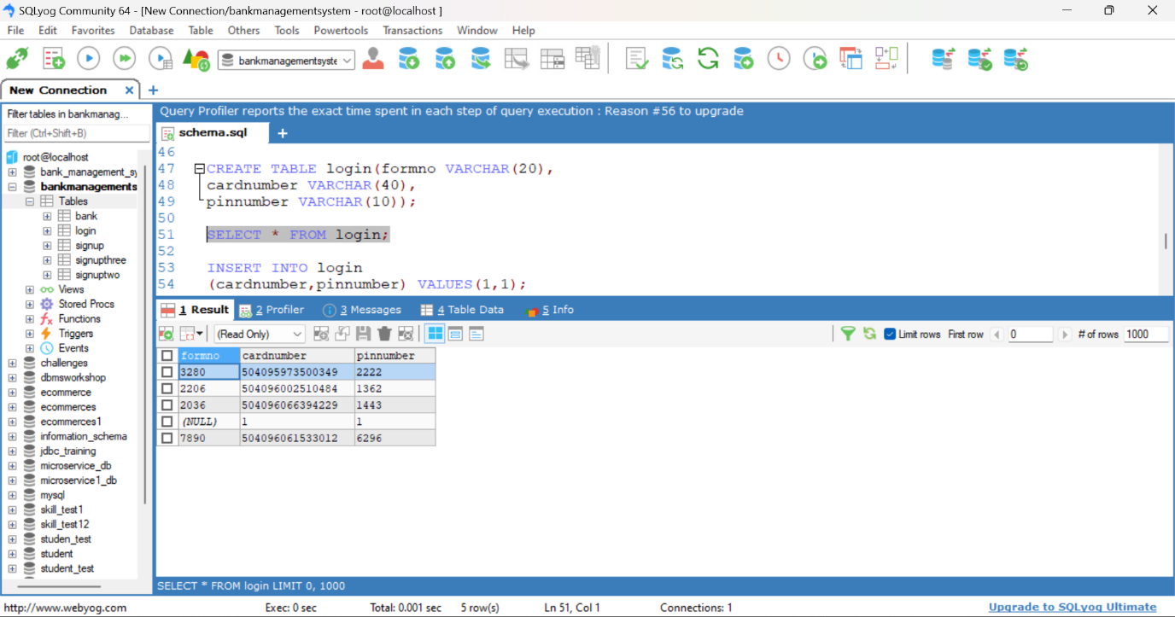

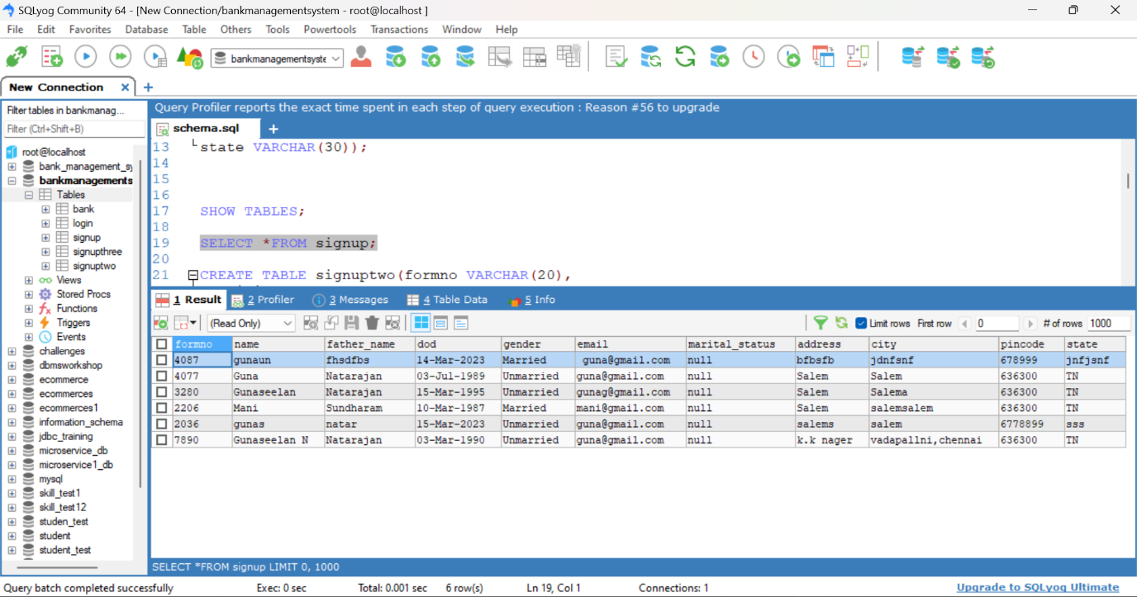

**Persional Details Table:**

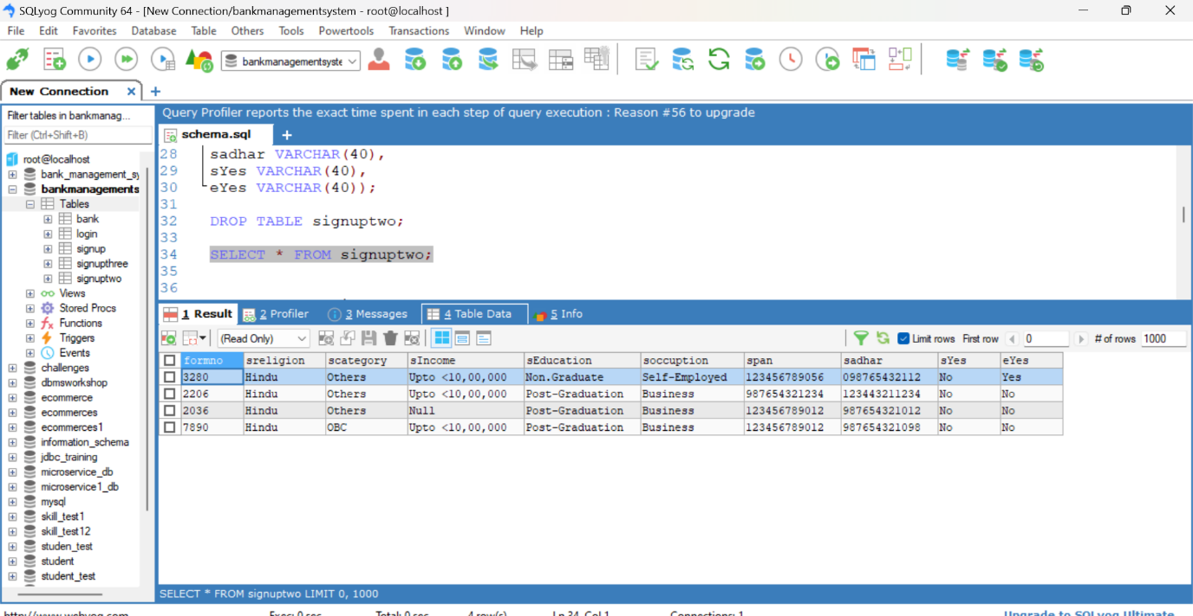

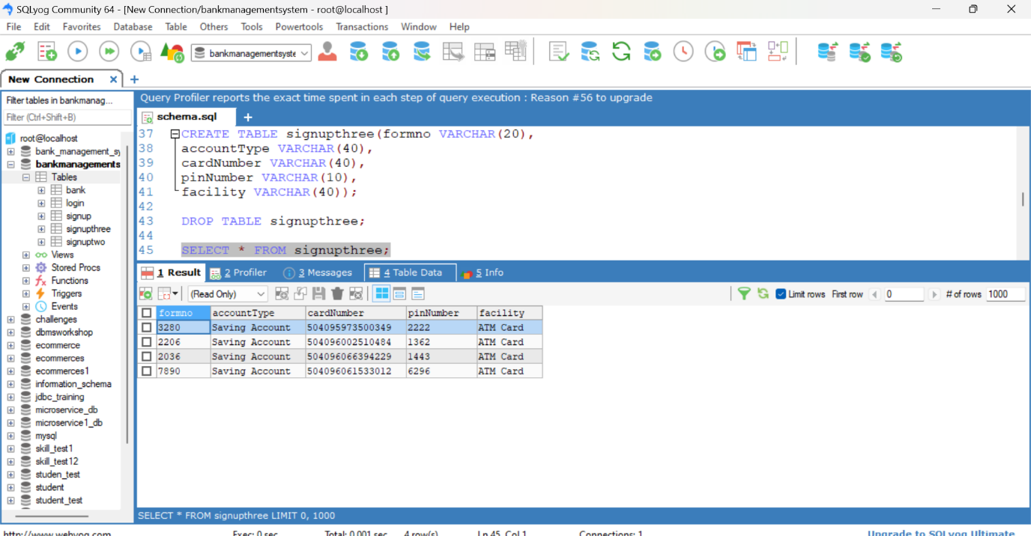

**Bank DataBase Table:**

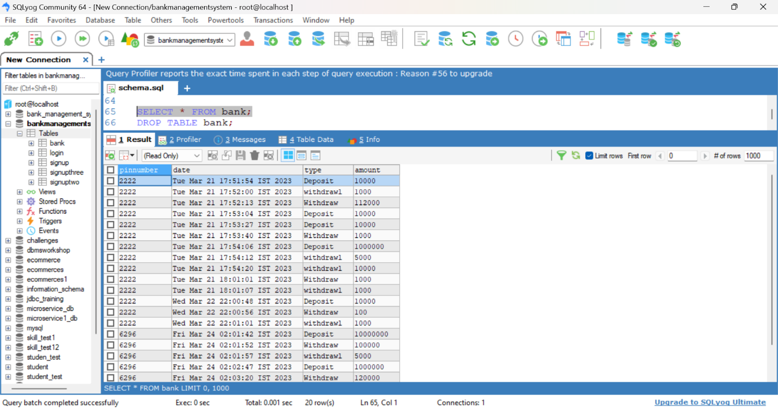

**Future work:**

In the future ATM Machine project create in the vice access security system implement in future and eye access system add then more secure in our account.